**MUQADDAS RASUL**

**BCS211038**

**LAB 12**

**Practice Tasks**

**Walk Through Task:**

.model small

.data

num db 5,2,5,6,1,32,6

max db 0

s db "calling function $"

s1 db "after calling function $"

s2 db "Inside Called function $"

.code

mov ax,@data

mov ds,ax

lea dx,s

mov ah,09

int 21h

call max_num

lea dx,s1

mov ah,09

int 21h

jmp xyz

max_num proc

lea dx,s2

mov ah,09

int 21h

mov ax,0

mov al,[num+0]

mov max,0

mov si,0

mov cx,6

l1:cmp [num+si],al

ja gg

jmp e

gg:

mov al,[num+si]

mov max,al

e:

inc si

loop l1

ret

max_num endp

xyz:

**OUTPUT:**

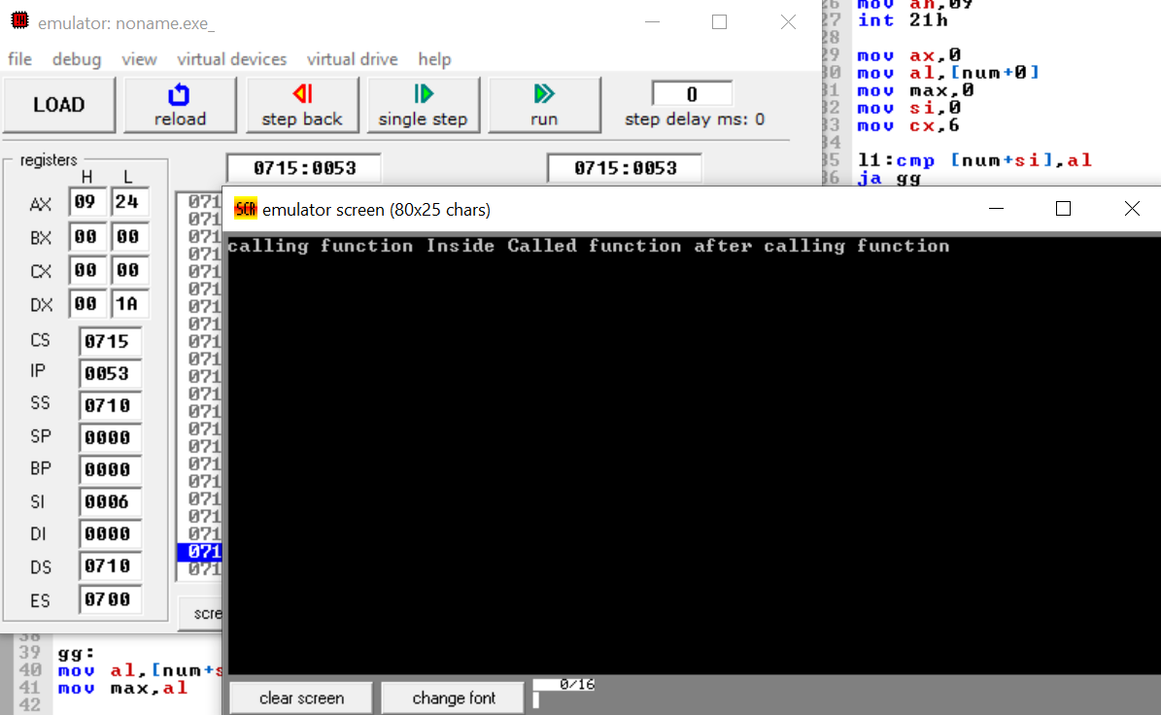

**Practice Task 2:**

.model small

.code

mov cx,5 ;cx

mov bx,cx

shape_print proc

l1:

mov cx,5 ;second loop counter

mov dl,01 ;store 1 in dl to start printing from 1

L2:

mov ah,02 ;display number

int 21h

inc dl ;Increment in dl register

loop l2

mov ah,02

mov dl,0dh ;carriage return

int 21h

mov dl,0ah ;line feed

int 21h

mov cx,bx

dec bx

loop l1

ret

shape_print endp

mov ah,4ch

int 21h

**OUTPUT:**

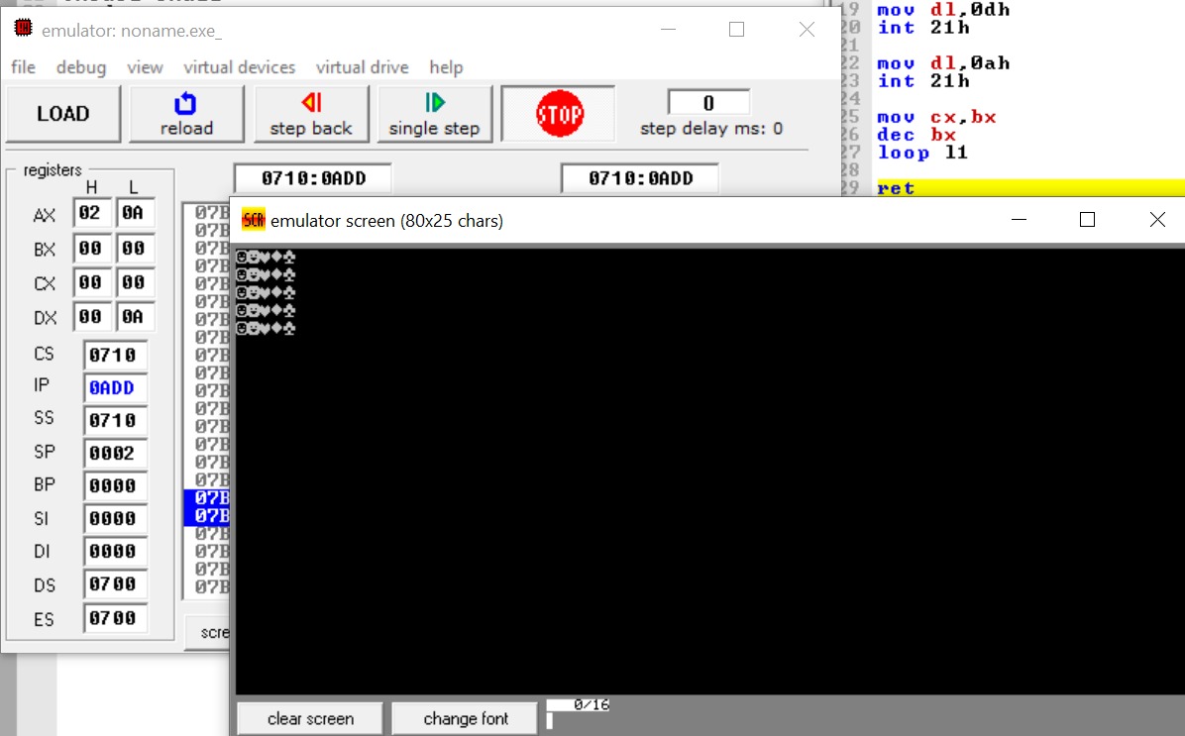

**PRACTICE TASK 3:**

.model small

.data

msg db "Enter a positive Integer $"

msg1 db 0ah,0dh,"This is a prime number$"

msg2 db 0ah,0dh,'This is not a prime number$$'

numb db ?

pcheck db 0

.code

mov ax,@data

mov ds,ax

lea dx,msg

mov ah,09

int 21h

mov ah,01

int 21h

sub al,48

mov numb,al

mov bl,02

div bl

sub al,128

mov cl,al

mov bl,02

L1:

mov al,numb

div bl

cmp ah,0

JE l2

jmp loo

L2:

inc pcheck

jmp printnp

loo:

inc bl

loop l1

mov bl,pcheck

cmp bl,0

JE printp

jmp printnp

printp:

lea dx,msg1

mov ah,09

int 21h

jmp done

printnp:

lea dx,msg2

mov ah,09

int 21h

done:

mov ah,4ch

int 21h

**OUTPUT:**

